Supplemental Data

Supplemental Figure 1. Hyperspy Code for FTIR Top View (referred to as “Aerial View”)

# # HyperSpy Code for FTIR Aerial View

# ## Loading tools and libraries

get_ipython().run_line_magic('matplotlib', 'qt')
import hyperspy.api as hs
import numpy as np
import matplotlib.pyplot as plt

# ## Reading Thermo OMNIC<sup>®</sup> FTIR data files

def load_omnic(filename, signal_title, save=False):
import os
import hyperspy.api as hs
from PyMca5.PyMcaIO import OmnicMap
omnic_file = OmnicMap.OmnicMap(filename)

reversed_data = omnic_file.data[::-1,:,::-1] # Need to reverse y and energy dims
sig = hs.signals.Signal1D(reversed_data)

sig.axes_manager[0].name = 'x'
sig.axes_manager[0].offset = 0
sig.axes_manager[0].scale = omnic_file.info['OmnicInfo']['Mapping stage X step size']
sig.axes_manager[0].units = '${\mu}m$'

sig.axes_manager[1].name = 'y'
sig.axes_manager[1].offset = 0
sig.axes_manager[1].scale = omnic_file.info['OmnicInfo']['Mapping stage Y step size']
sig.axes_manager[1].units = '${\mu}m$'

sig.axes_manager[2].name = 'Wavenumber'
sig.axes_manager[2].offset = omnic_file.info['OmnicInfo']['Last X value']
sig.axes_manager[2].scale = -1 * omnic_file.info['OmnicInfo']['Data spacing']
sig.axes_manager[2].units = '1/cm'

sig.metadata.General.title = signal_title

if save:
sig.save(os.path.splitext(filename)[0] + '.hspy')

return sig

# ## Loading file and visualizing data

s=load_omnic('Aerial 20um step 40 aperture.map','Aerial FTIR', True)
sig = hs.load('Aerial 20um step 40 aperture.hspy').isig[2000.:].inav[:,:-1]
sig.plot()

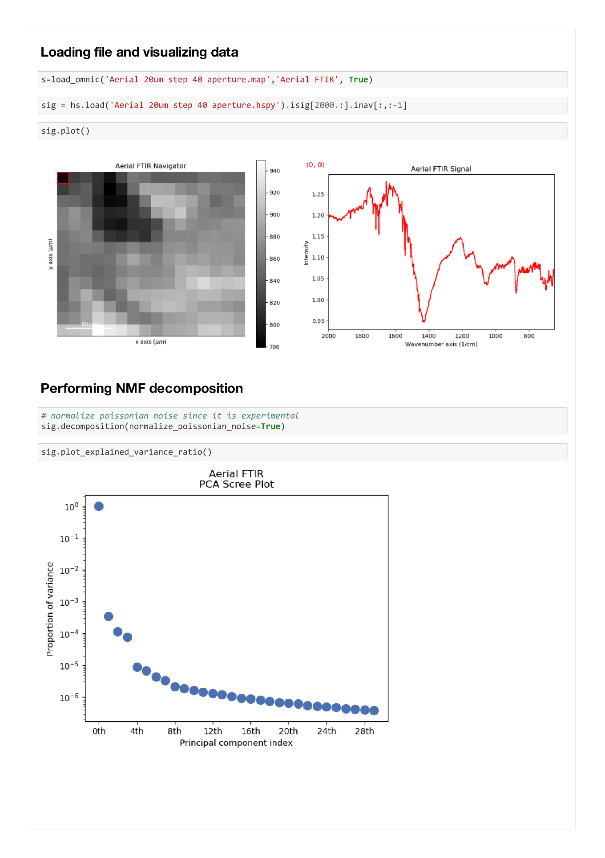

# ## Performing NMF decomposition

# normalize poissonian noise since it is experimental
sig.decomposition(normalize_poissonian_noise=True)
sig.plot_explained_variance_ratio()

# ## Performing NMF decomposition

# normalize poissonian noise since it is experimental
sig.decomposition(normalize_poissonian_noise=True)
sig.plot_explained_variance_ratio()

sig.decomposition(True, algorithm='nmf', output_dimension=3)
loadings = sig.get_decomposition_loadings()
hs.plot.plot_images(loadings, cmap='viridis',
per_row=2,
label=['NMF Factor {}'.format(i) for i in range(len(loadings))],
axes_decor='off', suptitle='NMF Loadings (Raw signal)',
padding={'wspace': .5, 'hspace':.1})
hs.plot.plot_spectra(sig.get_decomposition_factors(), style='mosaic')

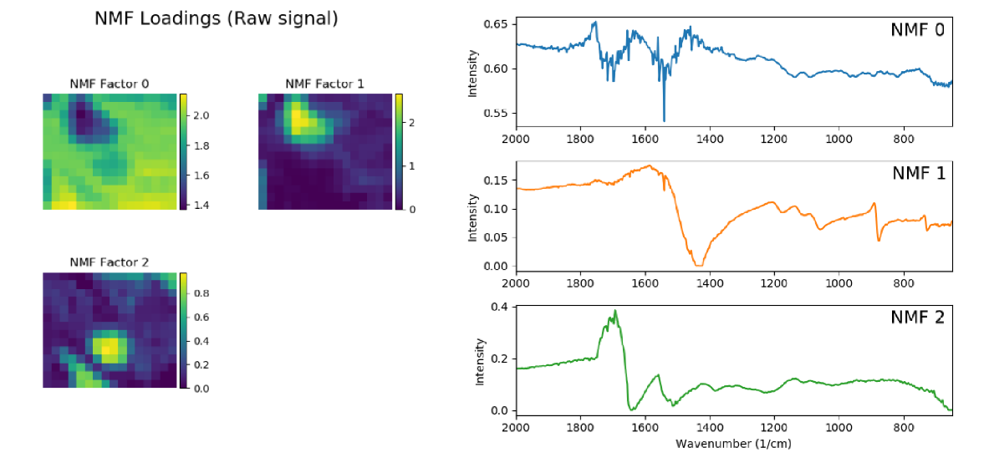

Supplemental Figure 2. Hyperspy Code for FTIR Cross-sectional View

# # HyperSpy Code for FTIR Cross-Sectional View

# ## Loading tools and libraries

get_ipython().run_line_magic('matplotlib', 'qt')
import hyperspy.api as hs
import numpy as np
import matplotlib.pyplot as plt

# ## Reading Thermo OMNIC<sup>®</sup> FTIR data files

def load_omnic(filename, signal_title, save=False):
import os
import hyperspy.api as hs
from PyMca5.PyMcaIO import OmnicMap
omnic_file = OmnicMap.OmnicMap(filename)

reversed_data = omnic_file.data[::-1,:,::-1] # Need to reverse y and energy dims
sig = hs.signals.Signal1D(reversed_data)

sig.axes_manager[0].name = 'x'
sig.axes_manager[0].offset = 0
sig.axes_manager[0].scale = omnic_file.info['OmnicInfo']['Mapping stage X step size']
sig.axes_manager[0].units = '${\mu}m$'

sig.axes_manager[1].name = 'y'
sig.axes_manager[1].offset = 0
sig.axes_manager[1].scale = omnic_file.info['OmnicInfo']['Mapping stage Y step size']
sig.axes_manager[1].units = '${\mu}m$'

sig.axes_manager[2].name = 'Wavenumber'
sig.axes_manager[2].offset = omnic_file.info['OmnicInfo']['Last X value']
sig.axes_manager[2].scale = -1 * omnic_file.info['OmnicInfo']['Data spacing']
sig.axes_manager[2].units = '1/cm'

sig.metadata.General.title = signal_title

if save:
sig.save(os.path.splitext(filename)[0] + '.hspy')

return sig

# ## Loading file and visualizing data

s=load_omnic('CS 20um step 40um A.map','CS FTIR', True)
sig = hs.load('CS 20um step 40um A.hspy').isig[2000.:]
sig.plot()

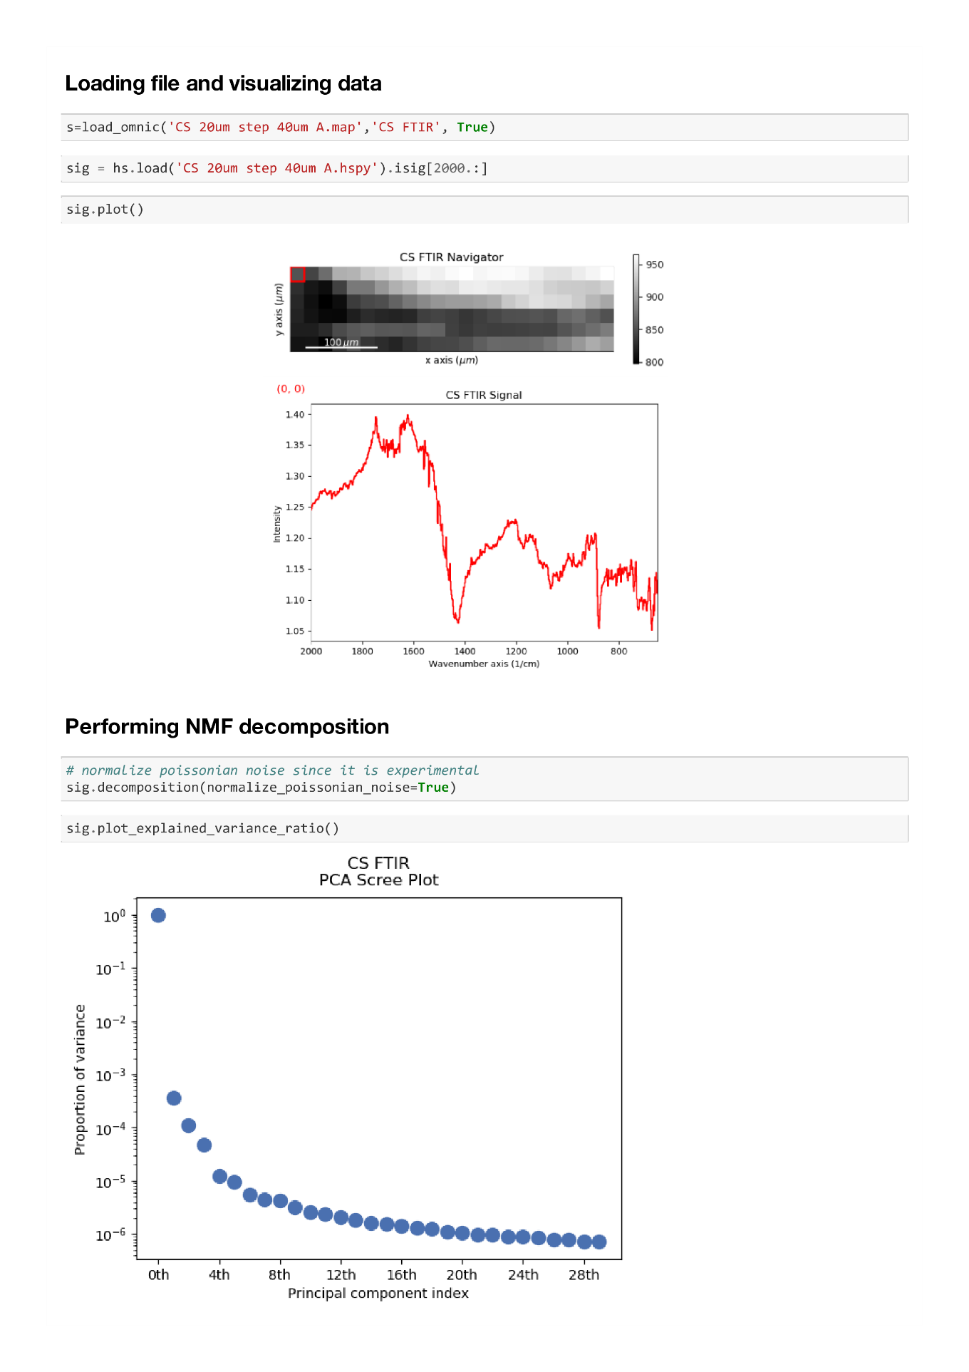

# ## Performing NMF decomposition

# normalize poissonian noise since it is experimental
sig.decomposition(normalize_poissonian_noise=True)
sig.plot_explained_variance_ratio()

sig.decomposition(True, algorithm='nmf', output_dimension=3)
loadings = sig.get_decomposition_loadings()
hs.plot.plot_images(loadings, cmap='viridis',
per_row=1,
label=['NMF Factor {}'.format(i) for i in range(len(loadings))],
axes_decor='off', suptitle='NMF Loadings (Raw signal)',
padding={'wspace': .5, 'hspace':.1})
hs.plot.plot_spectra(sig.get_decomposition_factors(), style='mosaic')

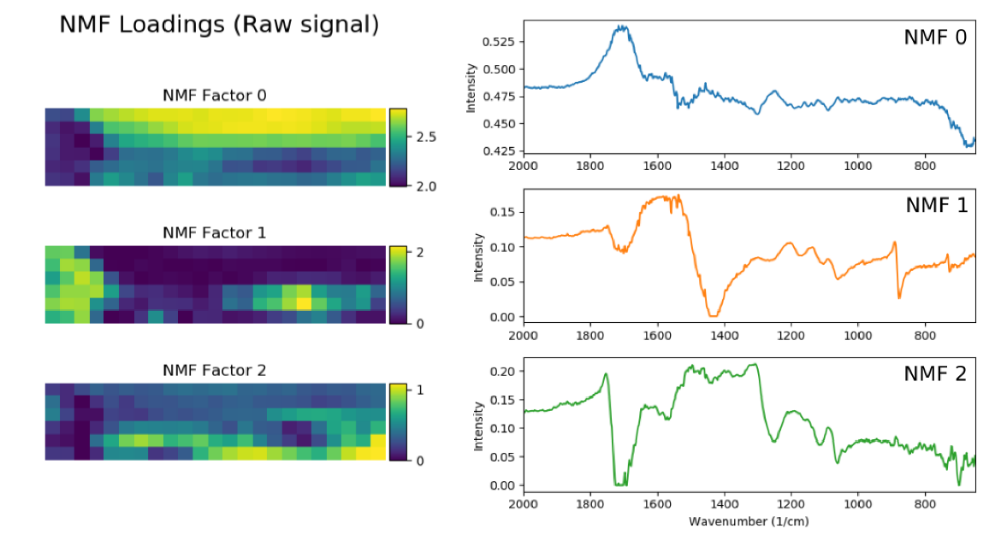

Supplemental Figure 3. ATR-FTIR spectra for Gel material
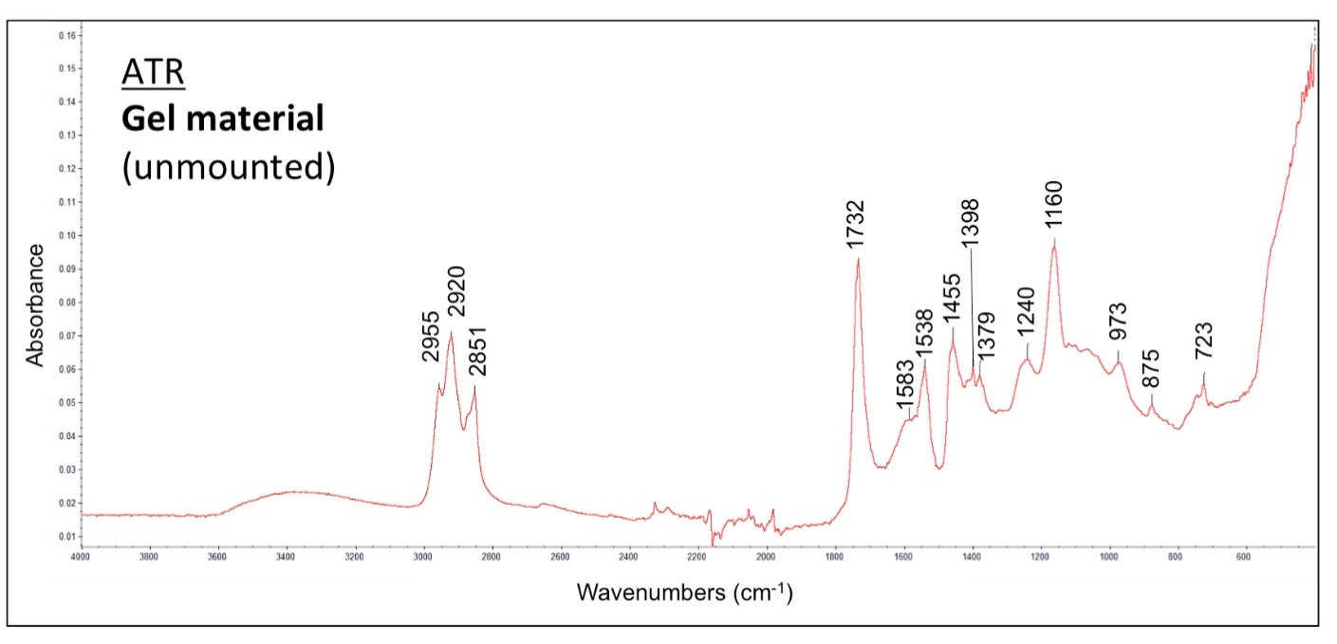

Supplemental Figure 4. ATR-FTIR Spectrum for Protrusion
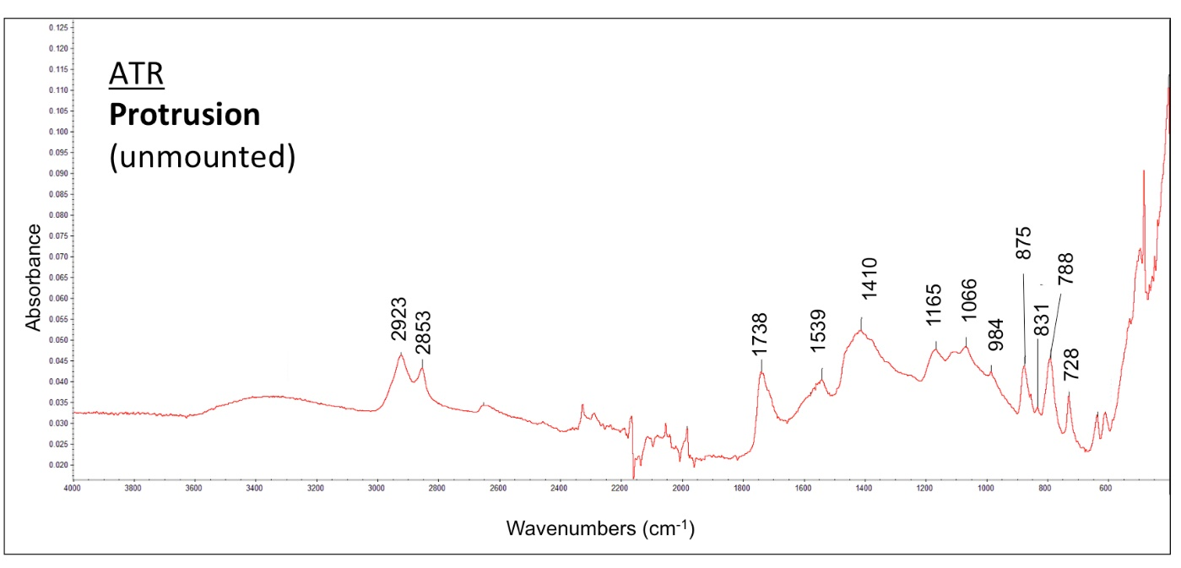

Supplemental Figure 5. ATR-FTIR Spectrum for Baseline Paint 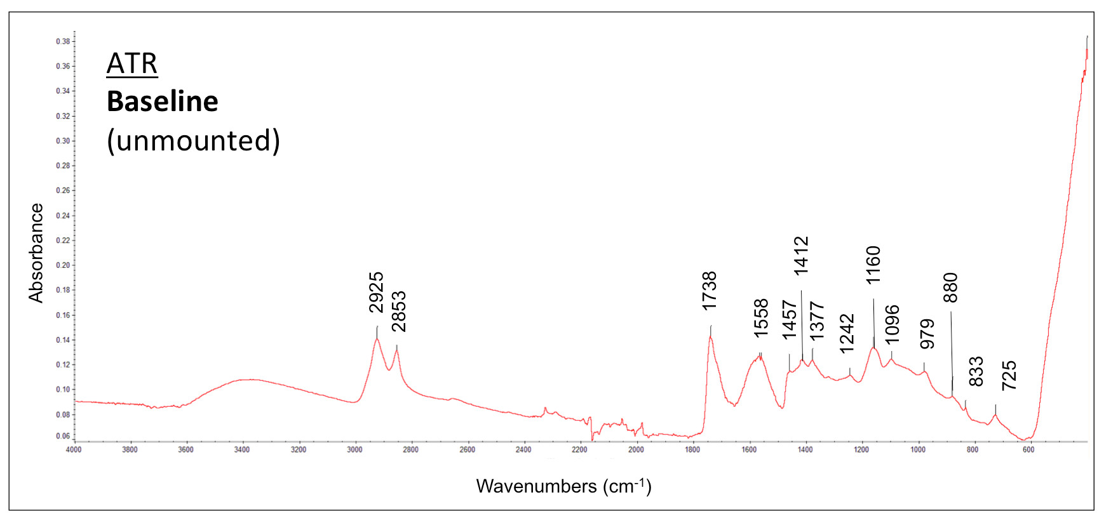

Supplemental Table I. Mass fraction of Elemental Concentrations in the Gel, Bio-Plastic®, and Zinc White with ± standard of error
 | C (%) | O (%) |  | S (%) |  | Cl (%) |  | Zn (%)
Gel | 74.71 ± 1.59 |  | 16.12 ± 1.57 |  | 0.75 ± 0.04 |  | 1.04 ± 0.10 |  | 6.75 ± 2.12
Bio-Plastic | 83.93± 0.71 | 15.67 ± 0.74 |  | < 0.5 |  | < 0.5 |  | < 0.5
Zinc white | 47.93 ± 2.80 | 13.76 ± 0.18 |  | < 0.5 |  | < 0.5 |  | 38.16 ± 2.88

Supplemental Figure 6. Profile scans of 33 regions of the gel material in cross-sectional view with semi-quantified EDX mass fraction for Zn concentration.
